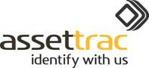Website update Spring 2019

Tagging technologies

We have extensive knowledge of all types of tagging techniques for a whole range of assets and environments, so do call us for advice based on the more detailed explanations as follows, including design and supply of samples.

**Unique identification tags**

Tag and label products are limited to discussion of those devices that can provide day to day asset management benefits, although we often supply barcode labels made of destructible vinyl in order to deter removal and improve theft deterrence. Advice on stencils, covert fluids such as Smart Water™ and microdots, holograms, access control, CCTV, or physical devices such as cables, alarms, and locks can be provided separately through our connections with specialist suppliers.

**A. Barcode labels**

Self adhesive barcode labels can be produced in a wide variety of materials, sizes, and designs. Unless the volume is very high and continuous, specialist suppliers are not much more expensive, and label art work is created by these professional printers and delivered by us to clients for approval. The print run is either brought by our auditors for fixing during the asset tagging phase or shipped for the client’s own use. Tags may be supplied in material to resist tampering or to withstand harsh environments if required.

Generic label Semi custom label

Property of   
 **Hugh James**CF10 1DY Tel 02920 224871

**ASSET REGISTERED** ABC 00001





ABC 00001

HJ 0001  
*Security marked and asset registered*

*Need a better custom label*

*NEED A BETTER MORE COLOURFUL LABEL WITH LOGO*

Fully custom label



CF10 1DY Tel 02920 224871



HJ 0001  
*Security marked and asset registered*

Property of   
 **Bridgewater Primary School** NN3 3AF Tel 01604 637056

In order to remove any problems with exporting data to XL, it is recommended that all sequential numbers avoid starting with a zero. The unique ID can also be a person or date if appropriate to the database circumstances

QR codes or Data Matrix codes are 2D barcodes capable of storing a lot more information than the 1D barcode, even an embedded link to a website, but the principal reasons for using them on assets is faster capture by a mobile phone camera and from a greater distance by specialist scanners, an example being a tagged lighting assembly on a high ceiling, or warehouse operation.

**B. Radio Frequency Identification, or RFID**This is a big subjectandto save space,comments are limited to passive ‘read only’ tags although we are well aware of the more specialist applications arising from read-write tags and battery powered active microchips. RFID tags and scanners are divided into low (LF), high (HF), and ultra high frequency (UHF) bands. LF is mainly concerned with animal applications although we also use it in our grave pegs as it is less affected by moisture. HF and UHF tags are supplied for applications in the commercial sector.

RFID uses data-embedded tags (attached to products just like barcodes), which are decoded via radio waves. RFID scanners have antennas, which emit radio-frequency signals in order to communicate with the tag antenna and wirelessly read its unique code, imprinted and locked in the chip’s circuitry at the time of manufacture.

Pros and cons of using barcode technology

It’s important to note that barcodes are still the most widely used tagging devices and will be for many years to come. The following bullet points will help you decide which technology is best for your business.

Barcode advantages

* Barcode systems can be easy to implement in small or large scale environments
* Barcodes can be printed in house or by a specialist on security material or laminated according to any threat.
* Barcode systems are cheaper than RFID
* The accuracy of barcodes is generally thought to be better than RFID
* Barcodes are a universal technology and can be read from basically any scanner or modern smart phone

Barcode disadvantages

* Line of sight required for interrogation.
* Barcode scanners usually have to be within 15 feet of the barcode in order to read its data, much less if the label is small.
* Barcodes are more vulnerable to interference and damage which renders them unreadable.
* Items must be scanned individually.
* Barcodes can be counterfeited or replicated.
* Barcodes contain only an alpha numeric code of up to 30 characters.
* Barcodes are read only and information cannot be updated or added.

RFID advantages

* RFID tags can be read without line of sight through most materials except metal.
* Tags can be paper based or encapsulated in durable plastic formats depending on the threat of interference or hostile conditions.
* Multiple tags can be read simultaneously
* RFID tags can be read from greater distances
* RFID tags have read/write capabilities..Information can be updated and added.
* Difficult to replicate.
* NFC tags (a variety of HF RFID) can be decoded by most modern smart phones without the need for separate RFID scanners, saving money

RFID disadvantages

* RFID tags can be up to ten times the cost of barcode labels dependent on microchip encapsulation, although the cost of a large volume of paper based NFC tags is more comparable
* RFID scanners ruggedized for the warehouse environment are generally more expensive than their barcode equivalents, especially the UHF versions.
* NFC tags have only a short ‘read range’.

RFID tags are available in a huge variety of formats, frequencies, and functionality to suit different circumstances and some shapes are as follows:-

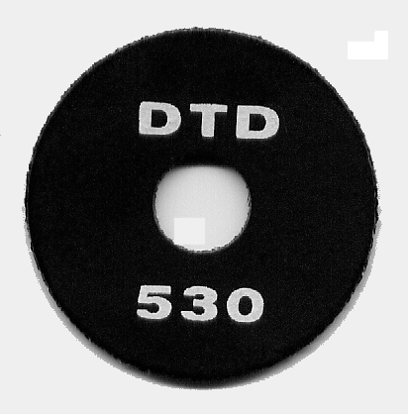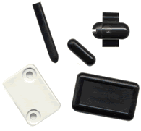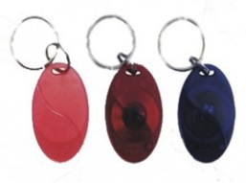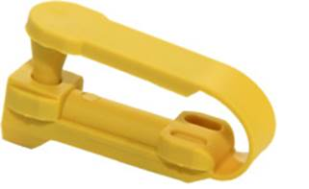

Lock tag for Zip fasteners Key fob tags Badges and nails Disc tag, various diameters

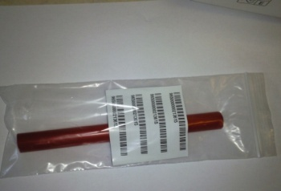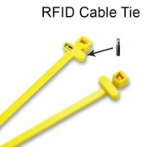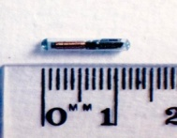

Injectable glass tag Cable tie tag Underground grave peg

Internet of Things (IOT)  
  
IOT technologies are developing at a fast rate and via a sensor essentially enable an asset to communicate with the software program without the need for a human intervention. Systems can be set up to call for maintenance when needed by monitoring temperature, pressure, vibration, moisture, or throughput measurements. We already have an IOT application in place for a client needing automatic weighing of commodity bags.