Website update Spring 2019

Solutions

**Cemeteries, crematoria, and natural burial grounds**

We have been supplying these venues within the bereavement services sector since 1999, and our knowledge of the practices and people involved is much enhanced by our membership of The Institute of Cemetery and Crematorium Management and whose website we have hosted since 2008   
([**www.iccm-uk.com**](http://www.iccm-uk.com)), and for whom we created branded software- ICCoMply.

This is run together with the **Bereavement Services Portal**, an online directory we created in 2004 of most active cemeteries, crematoria, and natural burial grounds with full contact details and editable by the operators themselves to keep it up to date.

We attend the Institute’s national conference and sponsor their events.  
  
Our other main activities within the sector are

* Epitrace grave marking system,
* Memorial Safety- onsite risk assessments and software management
* Asset registers

**Epitrace**

The underground marker peg has now been supplied to over 100 burial grounds since 1999 for the sole purpose of providing a long term unique identity to any grave that has no visible or limited memorialisation, often a feature of natural burial grounds. *Read more......... or Download brochure?*

**Epitrace**

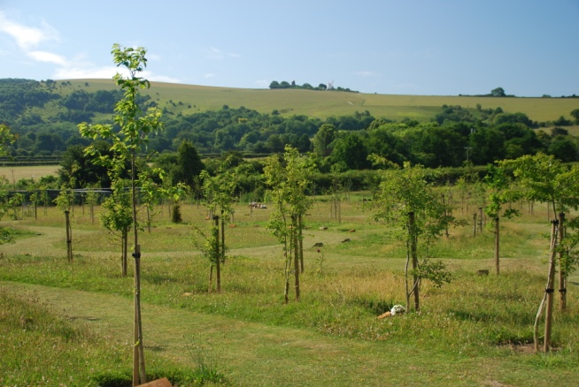

**Pinpointing the exact position   
 of unmarked graves, for ever!**

**◊ The Epitrace marker peg ensures you   
 always identify the right grave for   
 additional or adjacent burials, and   
 exhumations**

 *Embedded microchip*

*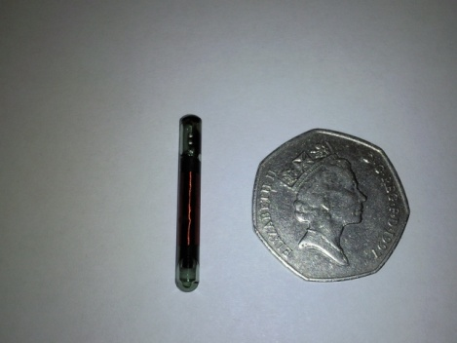***◊ Unique unalterable identification, indefinitely,   
 just like the microchip carried in millions of dogs and cats!**

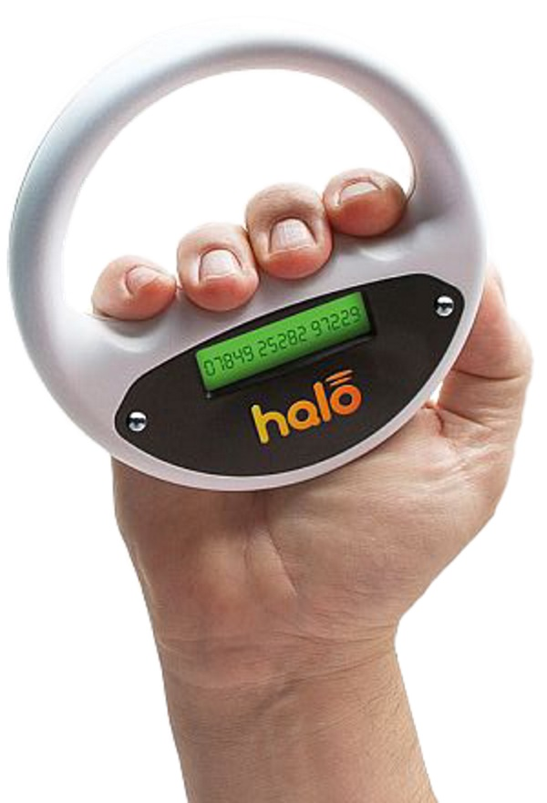**◊ Implanted easily underground near each grave, and   
 detected with a simple scanner, the peg’s unique number   
 is recorded in your register**

**◊ Vandal and weather proof, it ensures** *140mm* **the right grave is identified for subsequent   
 interments or exhumations**

**◊ Supplied to over 100 UK and overseas   
 operators, it adds peace of mind for you   
 and the bereaved**

**◊ Microchips can also mark cremated remains,**

**memorial trees, and plaques.** *Solid PVC rod*

Nail chip

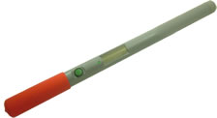

## Identifier tag

**Burial registers in the Clouds**

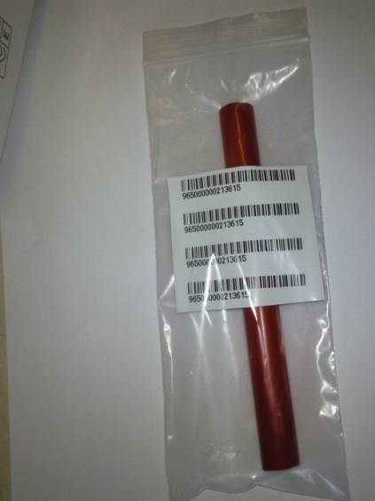  
Our AP Online program stores all your natural burial records   
  
for compliance purposes and provides a paperless link all the way to the burial or ashes plot.

**◊ Via Wi-Fi download your entire burial register to our   
  
 Epitrace app on your smart phone or tablet  
  
  
◊ Connect the pole reader via the Bluetooth function to  
 your mobile device**

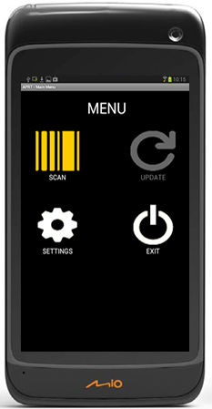**◊ Scan the grave peg with the pole reader which confirms  
 a successful read with a beep and chip number display**

**◊ The mobile device will instantly display your burial   
 record of the deceased set up in the office   
   
◊ Edit the record if necessary and your online register  
 will be updated automatically too  
  
◊ Epitrace online keeps an audit trail of each scan   
 and who added new records or made changes**



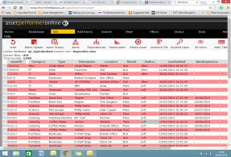[](http://www.google.co.uk/imgres?q=pictures+of+computers+and+laptops&hl=en&sa=X&biw=1122&bih=768&tbm=isch&prmd=imvns&tbnid=md4NBdxsc_g6TM:&imgrefurl=http://www.openitmag.com/2011/06/pros-and-cons-of-laptop-and-desktop-computers/&docid=7D8EKKY91guZIM&w=400&h=309&ei=eMlwTrCWAoeXOtKRzY8J&zoom=1)**◊ You can customise Epitrace online to store details of   
 funeral directors, next of kin, even costs, site maps   
 and plot photographs**

***Epitrace keeps a full history of all activity   
available 24/7 from anywhere***

**Memorial Safety**

Risk assessments and recording findings are a major and continuing responsibility for managers of burial grounds and closed churchyards. Paper based procedures are slow, error prone, and often require conversion to spreadsheets.

We provide two alternative solutions

1. For those organisations with limited staff resources, an onsite service for carrying out these checks efficiently using a mobile app and presenting a written report, *Read more.....or download the brochure, see below?*

**

**MEMORIAL SAFETY-ARE YOU HAPPY WITH THE CURRENT STATE OF YOUR CEMETERIES?**

**A new cost effective approach to safety inspections**

Many burial authorities have a very large number of memorials under their care. Due to the sheer volume and long term responsibility to maintain site safety, it is not practical or financially viable to physically test every memorial.

Some authorities have inspected each memorial in all their grounds, and this has proven time-consuming and very expensive. A typical cost for each memorial test is around £3.00.

ASSETtrac Ltd has a lot of experience in Health and Safety inspections so when a council local to us requested a cost effective methodology for inspecting their 30,000 memorials, our expertise and mobile technology was applied to the problem resulting in a robust solution **at a significantly reduced cost.** We duly carried out the inspections on a risk based approach in less than a week and the results were approved by the council’s insurers (Zurich), as a satisfactory risk assessment.

The process is fast, accurate and very cost–effective, with costs averaging around **15p per memorial.** Records may be delivered as a spreadsheet or maintained in our own online program, accessible whenever you like.



OUTPUTS- Typical reports

The table below shows the section risk assessments for those sections that were deemed to be low risk – and thus not requiring individual memorial assessments. An example of a low risk section may be a lawn section with headstones less than 1 metre in height in stable ground in an area of the cemetery that is not often visited.

|  |  |  |  |  |
| --- | --- | --- | --- | --- |
| **Section** | **Type** | **Result** | **Recommedation** | **Notes** |
| Childrens Section | Whole Section | Completed | Reinspect in 2021 | Safe section no remedial actions |
| Four Seasons | Whole Section | Completed | Reinspect in 2021 | Safe section no remedial actions |
| Muslim | Whole Section | Completed | Reinspect in 2021 | Safe section no remedial actions |
| S12 | Whole Section | Completed | Reinspect in 2021 | Safe section no remedial actions |
| S13 | Whole Section | Completed | Reinspect in 2021 | Safe section no remedial actions |
| S14 | Whole Section | Completed | Reinspect in 2021 | Safe section no remedial actions |
| S15 | Whole Section | Completed | Reinspect in 2021 | Safe section no remedial actions |
| S16 | Whole Section | Completed | Reinspect in 2021 | Safe section no remedial actions |
| S17 | Whole Section | Completed | Reinspect in 2021 | Safe section no remedial actions |
| S18 | Whole Section | Completed | Reinspect in 2021 | Safe section no remedial actions |
| S19 | Whole Section | Completed | Reinspect in 2021 | Safe section no remedial actions |
| S20 | Whole Section | Completed | Reinspect in 2021 | Safe section no remedial actions |
| S22 | Whole Section | Completed | Reinspect in 2021 | Safe section no remedial actions |
| S23 | Whole Section | Completed | Reinspect in 2021 | Safe section no remedial actions |
| S24 | Whole Section | Completed | Reinspect in 2021 | Safe section no remedial actions |

The following table is an extract from the results database showing individual memorials which failed the safety assessment.

|  |  |  |  |  |  |  |  |  |  |  |
| --- | --- | --- | --- | --- | --- | --- | --- | --- | --- | --- |
| **Section** | **Type** | **Name** | **YoD** | **Ht** | **Result** | **Lean** | **Base** | **Stability** | **Priority** | **Recommend** |
| S1 | CK | Augustus Powell | 1930 | 1.5 | FAIL |  | Joint Broken | Fail | 2 | Repair |
| S1 | CK | Herbert Hales | 1930 | 1.5 | FAIL | Fail | Joint Broken | Fail | 1 | Lay Flat |
| S1 | CK | Alexander Watt | 1930 | 1.5 | FAIL |  | Joint Broken | Fail | 1 | Lay Flat |
| S1 | CK | Emma Sanderson | 1930 | 1.5 | FAIL | Fail | Joint Broken | Fail | 1 | Lay Flat |
| S1 | CK | Edward Ross | 1939 | 1.5 | FAIL |  | Joint Broken | Fail | 1 | Lay Flat |
| S1 | CK | F J Mercer | 1931 | 1.5 | FAIL |  | Joint Broken | Fail | 1 | Lay Flat |
| S1 | CK | Jane Runcieman | 1932 | 1.5 | FAIL |  | Joint Broken | Fail | 1 | Lay Flat |
| S10 | C | Colin Rose | 1993 | 1.5 | FAIL |  | Joint Broken | Fail | 1 | Lay Flat |
| S11 | C | Jane Appelley | 1943 | 1.5 | FAIL | Fail | Joint Broken | Fail | 1 | Lay Flat |
| S2 | CK | Elizabeth Powell | 1936 | 1.5 | FAIL |  | Joint Broken | Fail | 1 | Lay Flat |
| S2 | CK | Ada Valentine | 1958 | 1.5 | FAIL |  | Joint Broken | Fail | 1 | Lay Flat |



1. Train burial authority staff on the paper free collection of records at the graveside and administration colleagues in the online software program which stores and manages all records, audit trails, alerts and photographs. *Read more.....or download the brochure?*



**Memorial safety in the Clouds**

Our AP Online program stores all your memorial risk assessments  
for compliance purposes and provides a paperless link all the way from the office to the graveside. We will set up the system to record any aspect of the memorial risk you wish to measure, including provision for cemetery plans and photographs. This will be consistent with your health and safety policy as well as ICCM best practice guidelines if you wish.

## MIO1

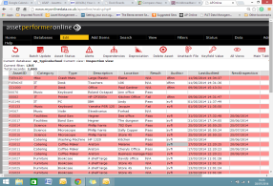**[](http://www.google.co.uk/imgres?q=pictures+of+computers+and+laptops&hl=en&sa=X&biw=1122&bih=768&tbm=isch&prmd=imvns&tbnid=md4NBdxsc_g6TM:&imgrefurl=http://www.openitmag.com/2011/06/pros-and-cons-of-laptop-and-desktop-computers/&docid=7D8EKKY91guZIM&w=400&h=309&ei=eMlwTrCWAoeXOtKRzY8J&zoom=1)◊ Via Wi-Fi download your risk register per cemetery   
 section or row to our mobile app on your smart   
 phone or tablet  
  
◊** **Search for the memorial number and the mobile   
 device will instantly display the last record status  
   
◊ Edit the record if necessary and your online database  
 will be updated automatically too  
  
◊ The program keeps an audit trail of each memorial  
 and who added new records or made changes**

**◊ The system can store records of all other regular  
 safety inspections, including trees, car parks, building  
 facilities, fire protection equipment, defibrillators.**